Clay Dunagan, MD, MS, Annual Patient Safety & Quality Symposium
Poster Instructions
CONSENT:
Abstracts are considered for submission even if submitted elsewhere previously or will be in the future. All presenters are consenting to allow their abstract to be posted in pdf format on Barnes-Jewish Hospital, St. Louis Children’s Hospital and Washington University School of Medicine Patient Safety intranet web pages and/or the Symposium registration website.

By submitting an abstract, you understand and agree that you may be contacted by e-mail up to 2 weeks after the Symposium by interested readers/reviewers with questions or thoughts Monday, March 3, 2025 - midnight, Tuesday, March 18, 2025, and it is expected that you will make a reasonable effort to respond. You will receive an email from bjc@confex.com. Any questions and responses will be posted to the Symposium website and made viewable to the public.

By submitting an abstract, you are agreeing that you (or a member of your team) will be present at your poster at all times during the review sessions. This year’s sessions will be:

9:25 to 9:55 (required)
10:55 to 11:40 (required)
12:40 to 13:10 (required)

All accepted abstracts (except those selected for oral presentation) are required to submit a digital poster and print it for the abstract room.

Abstract/Text Guidelines:
- The abstract is limited to 400 words.
- You may upload 1 supplementary figure or table (1) but is not required. This will not count towards the 400-word limit.
- Abstracts must be written in English.
- Any abbreviations used, must be included in parentheses first, following the full word(s).
- Editing will not be done prior to publication, so please proofread your abstract carefully.
- Include references as appropriate (if accepted as poster).

Your abstract MUST contain the following headers exactly as they are shown below. Headers are not included in the word count.
- Issue/Background
- Goal/Project/Method
- Results
- Lessons Learned/Conclusion

High Reliability Information:
It is not required to include information about highly reliable principles but can be considered for abstract inclusion. Here are the five tenets of high reliability for leaders and staff:
- High Reliability Organizations (HRO’s) are sensitive to operations – aware how processes and systems affect the organization.
- HRO’s are reluctant to accept simple explanations for problems – dig deeper to understand source of a problem(s).
HRO’s have a preoccupation with failure – encouraged to think of ways things can break down or go wrong.
- HRO’s defer to expertise – listen to those with developed knowledge for the task at hand.
- HRO’s are resilient – relentless, stay the course, seek new solutions.
- Gamble, M. (April 29, 2013), 5 Traits of High Reliability Organizations: How to Hardwire Each in Your Organization. Retrieved from:

http://www.beckershospitalreview.com/hospital-management-administration/5-traits-of-high-reliability-organizations-how-to-hardwire-each-in-your-organization.html

Considerations for your poster:

Safety/Quality Format
This format is intended for abstracts describing educational programs, observations, case studies, outbreak investigations, or other quality improvement activities, including descriptions of facility- or community-based programs or interventions, policies, and prevention models or methods.

- Title (with Authors): Ensure project title matches the story and outcomes.
- Issue/Background: Identify specific problem or need addressed. Provide a brief introduction and include important background information.
- Goal/Project/Methods: State the goal or aim of your project. Please be specific in your description of what you want to change. Describe in quantitative terms if appropriate; for example: Decrease central line infections in all nursing units by 60%. Describe the setting, intervention, and significant detail of the program.
- Results: Summarize results.
- Lessons Learned/Conclusions: Outline lessons learned and implications that might be helpful to others doing a similar project. Also include any challenges/barriers you and your team faced; how did you overcome them; if not, how is that affecting the outcome of your project.

Safety/Quality Format Example: (double-click for larger image)

Scientific Format
This format is intended for abstracts involving scientific research, such as randomized clinical controlled trials, case-controlled studies, cohort, observational, or descriptive studies. Abstracts should disclose primary findings and should not discuss works in progress with preliminary results.

- Title (with Authors): Ensure project title matches the story and outcomes.
- Background/Objectives: Provide a brief background and describe study objectives, hypothesis tested, and problem addressed.
- Methods: Describe study design, including setting, sample, sample size, subjects, intervention, and type of statistical analysis.
- Results: Summarize essential results as clearly as possible with appropriate statistical values (e.g. p-value, confidence intervals, odds ratio, relative risk, rate ratio, etc.).
- Conclusions: Conclusions must be supported by the findings. Concisely summarize findings and implications.

Scientific Format Example: (double-click for larger image)

Some additional tips:
- Display helpful tools – provide copies of audit tools, checklists, etc. that were key in the process.
- The first time an abbreviation/acronym is used, particularly if not widely known outside your area of expertise, please spell out the word(s) followed by the associated abbreviation/acronym.
- For easier reading, please use bullet points when applicable.
- Be sure to include your contact information, either on the story board or have some business cards near your storyboard.
- This is a link to last years accepted posters for reference. - Posters (confex.com)
(You will need to be registered for the symposium to access this link)

Set-up and Poster Dimensions:
When you arrive, please check in at registration. You will receive a number which will coincide with the location of an upright board/stand where you will display your poster. The posters will be displayed on the first floor of the Eric P Newman Center (EPNEC) in Great Room B and throughout the lobby.
We will provide a 4 foot tall/high x 8 foot wide board/stand to display your poster; however, when designing your poster please consider the inside dimensions of the board/stand:
- 45.0 inches is the limit for the poster height and 91.0 inches is the limit for the poster width to fit within the mounting.
- The poster must be capable of being mounted to the tack board (Face of board is covered with Velcro-receptive fabric or material similar to that used for cubical walls.).
- We will provide small push pins.
- If your poster is larger than the inside dimensions, please allow ample time to hang your poster. A vinyl poster is ideal over a foam board poster as these are difficult to hang on the display walls.
- The board/stand is double-sided and another author’s poster will be mounted behind your poster.
- You are encouraged to have handouts and business cards available.
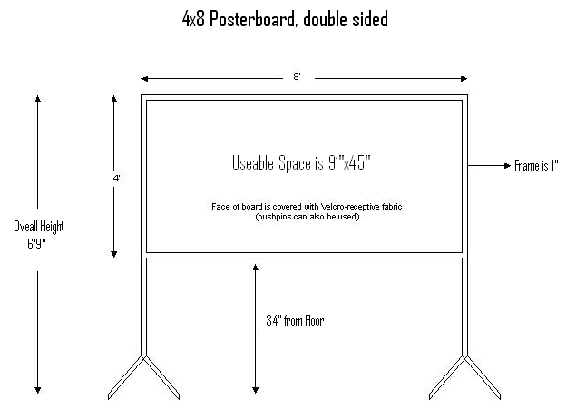
Please fill the space, please don’t make a small poster
If you need any assistance with your posters, please do not hesitate to email me: Robin.gray@bjc.org

