Clay Dunagan, MD, MS, Annual Patient Safety & Quality Symposium
Poster Instructions
CONSENT:
Abstracts are considered for submission even if submitted elsewhere previously or will be in the future. All presenters are consenting to allow their abstract to be posted in pdf format on Barnes-Jewish Hospital, St. Louis Children’s Hospital and Washington University School of Medicine Patient Safety intranet web pages and/or the Symposium registration website.

By submitting an abstract, you understand and agree that you may be contacted by e-mail up to 2 weeks after the Symposium by interested readers/reviewers with questions or thoughts Monday, March 9, 2026 - midnight, Tuesday, March 24, 2026, and it is expected that you will make a reasonable effort to respond. You will receive an email from bjc@confex.com. Any questions and responses will be posted to the Symposium website and made viewable to the public.

By submitting an abstract, you are agreeing that you (or a member of your team) will be present at your poster at all times during the review sessions. This year’s sessions will be:

10:10 to 10:50 (required)
11:50 to 12:50 (required)

All accepted abstracts (except those selected for oral presentation) are required to submit a digital poster and print it for the abstract room.

Abstract/Text Guidelines:
- The abstract is limited to 400 words.
- To upload an attachment (one (1) figure or table, this will not count towards the 400-word limit). Click on “Upload Method” below the “Copy and Paste Method”.
- Abstracts must be written in English.
- Any abbreviations used, must be included in parentheses first, following the full word(s).
- Editing will not be done prior to publication, so please proofread your abstract carefully.
- Include references as appropriate (if accepted as poster).
- Literature reviews or case studies will not be considered for scoring

Your abstract MUST contain the following headers exactly as they are shown in the checklist below. Headers are not included in the word count. Utilize checklist as method to confirm your submission addresses each header to meet scoring criteria for abstract acceptance. See Clear and Unclear examples. Please also reference appendix.

☐ Title (with Authors): Ensure project title matches the story and outcomes.
Clear Example: Aiming for Zero! CLABSI Reduction through TPN best practice
Unclear Example: Patient Safety issue at a hospital

☐ Issue/Background: Identify specific problem or need addressed. Provide a brief introduction and include important background information. Should include description of setting (e.g., level IV 150-bed neonatal intensive care unit).
Clear Example: Total parenteral nutrition (TPN) has been identified as an independent risk factor for an increased risk of Central Line Associated Blood Stream Infections (CLABSI) by ASPEN and the CDC. Adherence to practice guidelines may reduce the risk of infection. An increase in CLABSI in patients receiving TPN was identified in our academic, tertiary care medical center in 2022 where we have an average of 25-35 patients on TPN daily. A plan-do-check-act (PDCA) cycle identified and addressed practice gaps around supply access, lumen designation, TPN infusion interruptions, and daily maintenance to significantly reduce CLABSI in TPN patients.
Unclear Example: Blood stream infections were elevated. We needed to fix it and discussed at a few huddles.

☐ Methods (SMART(IE) AIM, Measures [outcome, process, balancing], intervention(s)/change; PDSA cycles – can include key driver diagram). Please be specific in your description of what you want to change. Describe in quantitative terms if appropriate; for example: Decrease central line infections in all nursing units by 60%. Describe the setting, intervention, and significant detail of the program.
Clear Example: In June 2022, 352 observational audits of 85 patients receiving TPN on 27 inpatient units were done by 2 designated RNs. Practice gaps were identified in 39% of patients. These gaps included not using a designated lumen and switching the lumen, not using a needleless access device (NAD), unlabeled tubing, and interrupting the infusion for care such as activity and hygiene. A root cause analysis identified lack of knowledge and supply availability as key issues. Collaboration with our pharmacy addressed supply issues by delivering tubing, filter, NAD, and label with TPN daily. Three pilot units were used to test improvements to address knowledge gaps and designated lumen labeling. Knowledge gaps were addressed with signage that was hung on the IV pole with TPN by clinical dieticians in September 2023. EPIC MAR administration instructions that matched the signage went live in November 2023. Nurses in the pilot areas evaluated 2 TPN designated lumen labels from November to January 2024 for durability. The pharmacy then updated the TPN kits to provide signage and the selected TPN lumen label for all TPN patients.
Unclear Example: We wanted to improve our clabsi rates and discussed at huddles and team meetings to bring awareness.

☐ Results/Outcome: Summarize results with data. Ideally use control or run charts to demonstrate measurement over time starting with baseline, intervention period, and then sustain period.
Clear Example: The TPN patient CLABSI rate in 2022 was 20.8% with 32 CLABSls. The 2023 TPN CLABSI rate was reduced to 12.7% with 20 infections. For 2024, the TPN CLABSI rate has decreased to 8.3% with 12 infections. This work has reduced CLABSI by 12.5% and sustained the improvement. Staff report improved satisfaction with the just in time education, supply delivery with TPN, and MAR update.
Unclear Example: We’ve shown one month of improvement, more data to follow.

☐ Lessons Learned/Conclusions: Outline lessons learned and implications that might be helpful to others doing a similar project. Also include any challenges/barriers you and your team faced; how did you overcome them; if not, how is that affecting the outcome of your project. Tell the story and include spread plan.
Clear Example: Staff input and multiprofessional collaboration between nursing, pharmacy, and dieticians has eliminated practice gaps and led to significant CLABSI reduction in patient receiving TPN at our academic medical center.
Unclear Example: Working together as a team helped us achieve results and look forward to continued improvements.

High Reliability Information:
It is not required to include information about highly reliable principles but can be considered for abstract inclusion. Here are the five tenets of high reliability for leaders and staff:
- High Reliability Organizations (HRO’s) are sensitive to operations – aware how processes and systems affect the organization.
- HRO’s are reluctant to accept simple explanations for problems – dig deeper to understand source of a problem(s).
HRO’s have a preoccupation with failure – encouraged to think of ways things can break down or go wrong.
- HRO’s defer to expertise – listen to those with developed knowledge for the task at hand.
- HRO’s are resilient – relentless, stay the course, seek new solutions.
- Gamble, M. (April 29, 2013), 5 Traits of High Reliability Organizations: How to Hardwire Each in Your Organization. Retrieved from:

http://www.beckershospitalreview.com/hospital-management-administration/5-traits-of-high-reliability-organizations-how-to-hardwire-each-in-your-organization.html

Some additional tips if accepted for poster presentation:
- Display helpful tools – provide copies of audit tools, checklists, etc. that were key in the process.
- The first time an abbreviation/acronym is used, particularly if not widely known outside your area of expertise, please spell out the word(s) followed by the associated abbreviation/acronym.
- For easier reading, please use bullet points when applicable.
- Be sure to include your contact information, either on the story board or have some business cards near your storyboard.
- This is a link to last years accepted posters for reference. - Posters (confex.com)
(You will need to be registered for the symposium to access this link)
- See appendix for PDSA and Key Driver Diagram examples of PI tools; and poster examples.

Set-up and Poster Dimensions:
When you arrive, please check in at registration. You will receive a number which will coincide with the location of an upright board/stand where you will display your poster. The posters will be displayed on the first floor of the Eric P Newman Center (EPNEC) in Great Room B and throughout the lobby.
We will provide a 4 foot tall/high x 8 foot wide board/stand to display your poster; however, when designing your poster please consider the inside dimensions of the board/stand:
- 45.0 inches is the limit for the poster height and 91.0 inches is the limit for the poster width to fit within the mounting.
- The poster must be capable of being mounted to the tack board (Face of board is covered with Velcro-receptive fabric or material similar to that used for cubical walls.).
- We will provide small push pins.
- If your poster is larger than the inside dimensions, please allow ample time to hang your poster. A vinyl poster is ideal over a foam board poster as these are difficult to hang on the display walls.
- The board/stand is double-sided and another author’s poster will be mounted behind your poster.
- You are encouraged to have handouts and business cards available.

Please fill the space, please don’t make a small poster. If you need any assistance with your posters, please do not hesitate to email me: Robin.gray@bjc.org

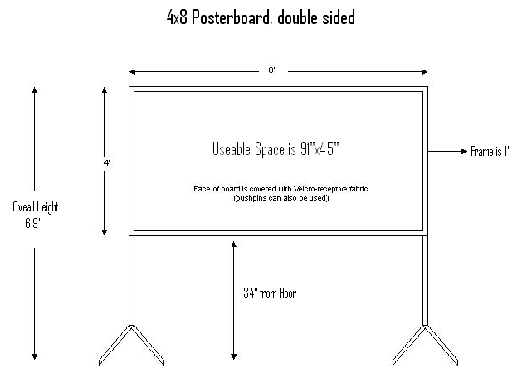
APPENDIX:
PDSA Example:
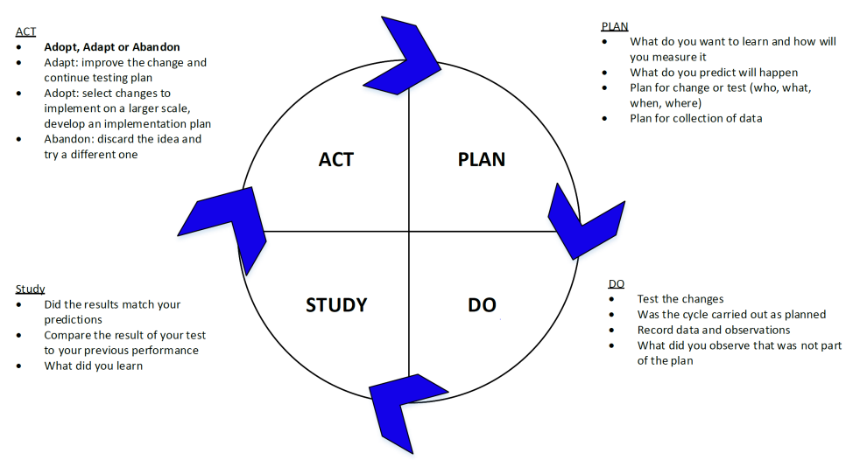
Key Driver Diagram Example:
Global aim: Overarching goal
Smart aim: What will be improved, by how much, for whom, and by when.
Key Drivers: Visual display of team’s theory of what “drives” or contribute to the achievement of a project aim. Show relationship between the overall aim of the project, the primary drivers (most important influencer) that contribute directly to achieving the aim. The Secondary drivers are interventions/actions. Strong relationships of interventions use solid lines, weaker relationships use dotted lines.
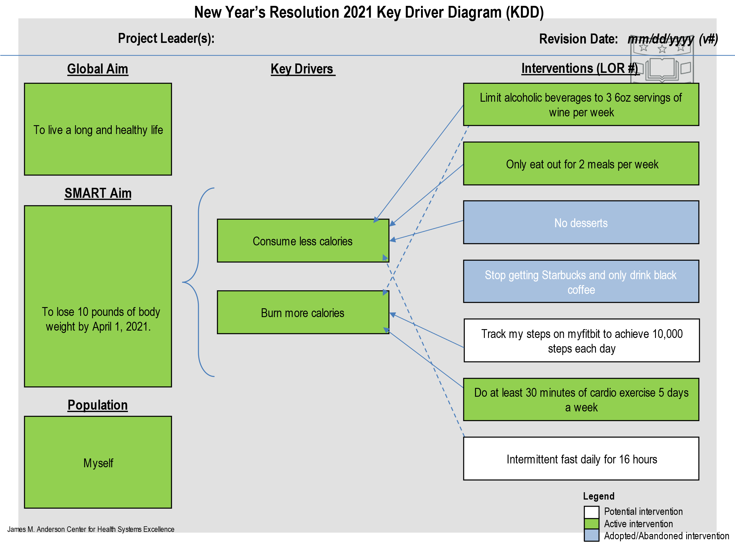

IHI Poster example:
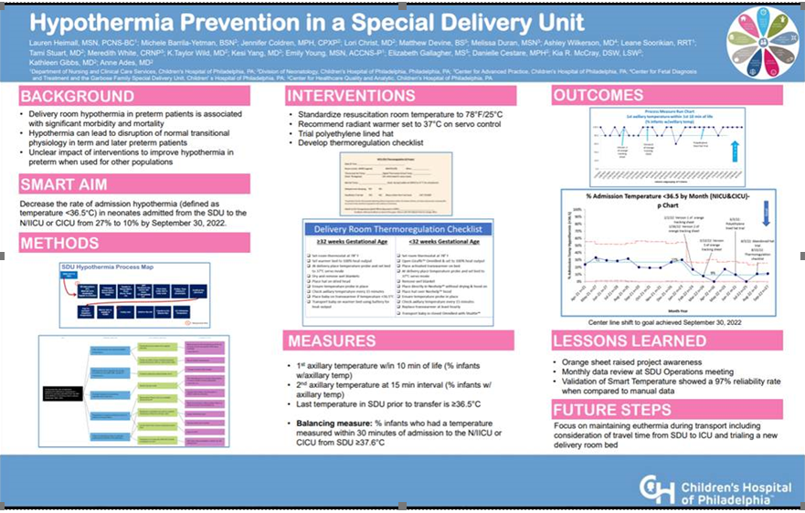

Safety/Quality Format Example: (double-click for larger image)
This format is intended for abstracts describing educational programs, observations, outbreak investigations, or other quality improvement activities, including descriptions of facility- or community-based programs or interventions, policies, and prevention models or methods.

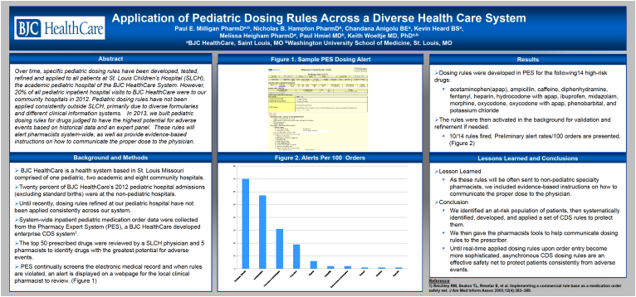

Scientific Format Example: (double-click for larger image)
This format is intended for abstracts involving scientific research, such as randomized clinical controlled trials, case-controlled studies, cohort, observational, or descriptive studies. Abstracts should disclose primary findings and should not discuss works in progress with preliminary results.

